

2020 Census enterprise architecutre and infrastructure transition plan

Count everyone once in the right place



May 1, 2017

Nicholas Vilailack, Linus freeman, Junxiang Wang

George Mason University

INFS 774: Enterprise Architecture  
Professor Barry Barlow

Contents

1. Team member responsibilities 3

2. Census Bureau Mission 3

What Data We Collect & When 3

How Our Data Are Used 4

3. The Summary of 2020 Census Enterprise Architecture and Infrastructure Transition Plan(CEAITP) 5

4. 2020 Census EA Framework Selection and Customization 5

5. 2020 Census Business Architecture Domain View 8

2020 CEAITP Purpose Strategies: 8

Four Key Innovation Areas: 9

Operational Design Overview 10

Business Architecture Overview 13

Current Business Architecture 14

Target Business Architecture 16

Two Touchpoints for Address Canvassing 18

Here is the Level-0 Activity Model for the overall Address Canvasing workflow: 19

Here is the Level-1 Sub-Activity Model for [In-Office] Address Canvasing workflow: 20

Here is the Level-1 Sub-Activity Model for [In-Field] Address Canvasing workflow: 20

6. Summary of the system view from the 2015 NCT to the 2020 Census. 21

7. The System View 22

8. The Technical view 28

IT Infrastructure 28

Service Oriented Architecture (SOA) 28

Mobile Technology - Device as a Service (DaaS) 29

Enterprise Cloud 29

Disaster Recovery and Continuity of Operation Plan (COOP) 30

Security Architecture 30

Program-Enterprise-System Quality 30

Scalability & Performance 31

Availability & Reliability 32

Transition Approach 33

Transition Steps 33

Phased Testing 34

Transition Tasks & Activities 34

Current Architecture (As-is Architecture) 35

Infrastructure Architecture 35

Security Architecture 35

Quality Architecture 35

Target Architecture (To-be Architecture) 36

Infrastructure Architecture 36

Infrastructure Domains 36

Security Architecture 36

Quality Architecture 37

Data Quality Management 37

Data Quality in Systems 37

9. References 38

# Team member responsibilities

|  |  |
| --- | --- |
| Team Member | Assignment(s) |
| Linus Freeman | EA Framework Selection and Customization  Enterprise Architecture Business View |
| Nicholas Vilailack | Enterprise Architecture System View Project Report Overview |
| Junxiang Wang | Enterprise Architecture Technical View  EA Framework Overview |

# Census Bureau Mission

The Census Bureau's mission is to serve as the leading source of quality data about the nation's people and economy. We honor privacy, protect confidentiality, share our expertise globally, and conduct our work openly.

We are guided on this mission by scientific objectivity, our strong and capable workforce, our devotion to research-based innovation, and our abiding commitment to our customers.

**Our Authority**

The Census Bureau operates under Title 13 and Title 26 of the U.S. Code.

**Our Goal**

Our goalis to provide the best mix of timeliness, relevancy, quality and cost for the data we collect and services we provide.

**What Data We Collect & When**

**Decennial Census of Population and Housing**

The U.S. census counts every resident in the United States. It is mandated by Article I, Section 2 of the Constitution and takes place every 10 years.

**Economic Census**

The Economic Census is the U.S. government's official five-year measure of American business and the economy.

**Census of Governments**

Identifies the scope and nature of the nation's state and local government sector including public finance and public employment and classifications.

**American Community Survey (ACS)**

The American Community Survey is the premier source for information about America's changing population, housing and workforce.

**Our Surveys & Programs**

Our surveys provide periodic and comprehensive statistics about the nation. This data is critical for government programs, policies, and decision-making.

**Economic Indicators**

The Census Bureau releases fourteen different reports on key economic indicators.

**How Our Data Are Used**

**To determine the distribution of Congressional seats to states.**

* Mandated by the U.S. Constitution
* Used to apportion seats in the U.S. House of Representatives
* Used to define legislature districts, school district assignment areas and other important functional areas

Find out about the 2020 Census Redistricting Data Program

**To make planning decisions about community services, such as where to:**

* Provide services for the elderly
* Build new roads and schools
* Locate job training centers

**To distribute more than $400 billion in federal funds to local, state and tribal governments each year.**

Census data informs how states and communities allocate funding for:

* Neighborhood improvements
* Public health
* Education
* Transportation
* Much more

**To provide Age Search information for:**

* Qualifying for Social Security and other retirement benefits
* Passport applications
* Proving relationship in settling estates
* Researching family history or a historical topic

# The Summary of 2020 Census Enterprise Architecture and Infrastructure Transition Plan(CEAITP)

**Business goals**

The (CEAITP) focuses on multi-year transition from 2015 solution architecture to the 2020 target architecture . The business goals of (CEAITP) are:

* Reengineering Address Canvassing;
* Optimizing Self-Response;
* Utilizing Administrative Records and Third-Party Data; and
* Reengineering Field Operations.

**Purposes and strategy**

The purpose of the 2020 CEAITP is to communicate and inform the transition phases to the stakeholders, to support the 2020 Operational Plan, to guarantee the safety of 2020 Census Program and to meet system requirement for scalability, reliability, and availability.

The 2020 CEAITP is incremental by nature, has detailed timelines for various architecture domains from current architecture to the target architecture and aims to maximize the utility of Enterprise standards, pattern and Programs.

# 2020 Census EA Framework Selection and Customization

Scope: The Census Bureau is an agency of the Commerce Department

The initial list of possible EA Framework selections could be:

1. The Zachman Framework
2. Federal Enterprise Architecture Framework (FEAF)
3. The Open Group Architecture Framework (TOGAF)
4. Enterprise Architecture Planning (EAP)

**Considerations:**

The Zachman Framework handles large scale complexity potentially better than the FEAF and TOGAF frameworks.

But the Census Bureau Enterprise Architecture scope is only for the individual agency.

So the Zachman Framework may be overkill and not the best fit.

FEAF, TOGAF, and EAP are the remaining frameworks being considered now.

TOGAF might be a lighter weight framework that would be a better fit than FEAF.

But because the Census Bureau needs a customized simpler version for their framework, EAP is chosen over TOGAF with a customized added top level Strategy View and two cross cutting views of Security and Quality (data quality, scalability, reliability and performance).

It is determined that EAP with customization offers the least complexity for structuring the 2020 Census Bureau Enterprise Architecture and Infrastructure Transition Plan.

**Rationale:** EAP is simpler to adopt, adapt, customize and tailor to the needs of the Census government agency.

The 2020 Census architecture is described in the context of the seven domains as shown in Figure 5-1.

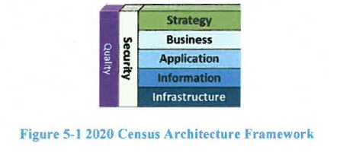

**2020 Census EAP Framework Customization**

The **Strategy Domain** consists of the program vision and mission level business requirements.

The **Business Domain** describes business goals and business operations.

The **Application Domain** describes the application areas and their respective systems and services.

The **Information Domain** describes the enterprise information and data dictionary.

The **Infrastructure Domain** describes the supporting segments and operations.

The **Security Domain** describes the security features and mechanisms throughout all of the other domain areas.

The **Quality Domain** describes the support for data quality, scalability, reliability, and performance dimensions.

# 2020 Census Business Architecture Domain View

The [2020 Census Enterprise Architecture and Infrastructure Transition Plan] (CEAITP) helps to realize the desired Solution Architecture that can fulfill the business goals of achieving cost efficient Census via modern technology, and implementing innovative Census operations as laid out in the 2020 Census Operation Plan for:

•Reengineering Address Canvassing;

•Optimizing Self-Response;

•Utilizing Administrative Records and Third-Party Data; and

•Reengineering Field Operations.

The 2020 CEAITP is designed to support the 2020 Operational Plan. With a phased approach aligned with the Census Tests, the 2020 CEAITP aims to ensure that the 2020 Census Program is not at risk of having to integrate solutions too late in the planning cycle. The sequencing timeline in the 2020 CEAITP shows that by the start of the 2018 End-to-End test, the majority of the business capabilities and systems must be in place. In addition, the Solution Architecture with its systems and services must be designed to meet the requirements for scalability, reliability, and availability.

## 2020 CEAITP Purpose Strategies:

The 2020 CEAITP is developed according to three strategies:

•First, the transition process is incremental by nature, as the Solution evolves from the current to target state. The Census Tests will demonstrate the progress of the implementation of the Business operations, and the capabilities provided by the Applications, and the IT Infrastructure.

•Second, the sequencing of the 2020 CEAITP has timelines for the architecture domains Business, Application, Information, Technical, Security, and Quality-, and consists of evolving these domains from the current state to the target state. The technical quality attributes of scalability, availability, reliability, resilience, and security are factored in the evolution of the 2020 Solution and propagated down to the levels of IT systems, services, and infrastructure components.

•Third, the transition maximizes the utilization of Enterprise standards, patterns and Programs, including CEDCaP and CEDSCI, and aims at consolidating similar capabilities into a common service or system. The modernization of the 2020 Solution will be enabled by emerging technologies that are SOA, Cloud, Mobile, and Web, while adhering to Federal directives for Cloud First, API, and Shared Services.

Finally, the 2020 Census Enterprise Architecture and Infrastructure Transition Plan is a living document, that will drive the collaborative process and be refined or adjusted to minimize risk and maximize efficiency, yet meet the ultimate timelines of 2018 End-to-End Test and 2020 Census Day.

## Four Key Innovation Areas:

As mentioned above, four key innovation areas that are the focus of the 2020 Census design:

•Reengineering Address Canvassing

•Optimizing Self-Response

•Utilizing Administrative Records and Third-Party Data

•Reengineering Field Operations

**Reengineering Address Canvassing** is designed to reduce the amount of in-field labor required to update the Master Address File (MAF) and associated technical products used for assessing where to count. In-office Address Canvassing (AdCan) will be completed nationwide using imagery and address files shared by local and tribal governments. In-office AdCan is less expensive than in-field AdCan, but infield AdCan will still be required in up to 25% of all addresses. The plans for reengineered address canvassing are expected to reduce field workload by up to 75% by adding new addresses to the Census Bureau's address frame using Geographic Information Systems (GIS) and aerial imagery instead of sending Census employees to walk and physically check all the census blocks.

**Optimizing Self-Response** is designed to maximize the degree to which the respondent pool can successfully self-respond, reducing the cost of paper data capture and in-person Nonresponse Follow-up (NRFU). By encouraging the population to respond to the 2020 Census using the Internet or the telephone, the need for more expensive options are reduced.

**Utilizing Administrative Records and Third-Party data** is designed to reduce field workload by improving the efficiency of NRFU operations. By using these alternative sources of data, NRFU operations can eliminate the need for multiple unproductive visits to housing units that are vacant, abandoned, or otherwise unoccupied. It is expected that some nonresponding housing units will be enumerated in the 2020 census by using administrative records. The 2020 Census will enumerate many Group Quarters (GQs) through reference to administrative-type, third-party data. By using data the public has already provided to the government and data available from commercial sources, the Census Bureau can realize savings to focus additional visits in areas that have been traditionally hard to enumerate.

**Reengineering Field Operations** is designed to increase the efficiency of field operations, allowing managers and field workers to be more productive and effective. Combining new operational control software and case management tools with GPS-enabled devices will improve the efficiency of field workers and allow faster and more accurate management of field worker labor and travel expenses.

Using sophisticated operational control systems, Census employees can follow up with nonresponding housing units and keep better track of the daily progress of field workers.

**Program overview**

Figure 2-1 provides a high-level overview of how the 2020 Census will be conducted. This design reflects a flexible approach that takes advantage of new technologies and data sources while minimizing risk.

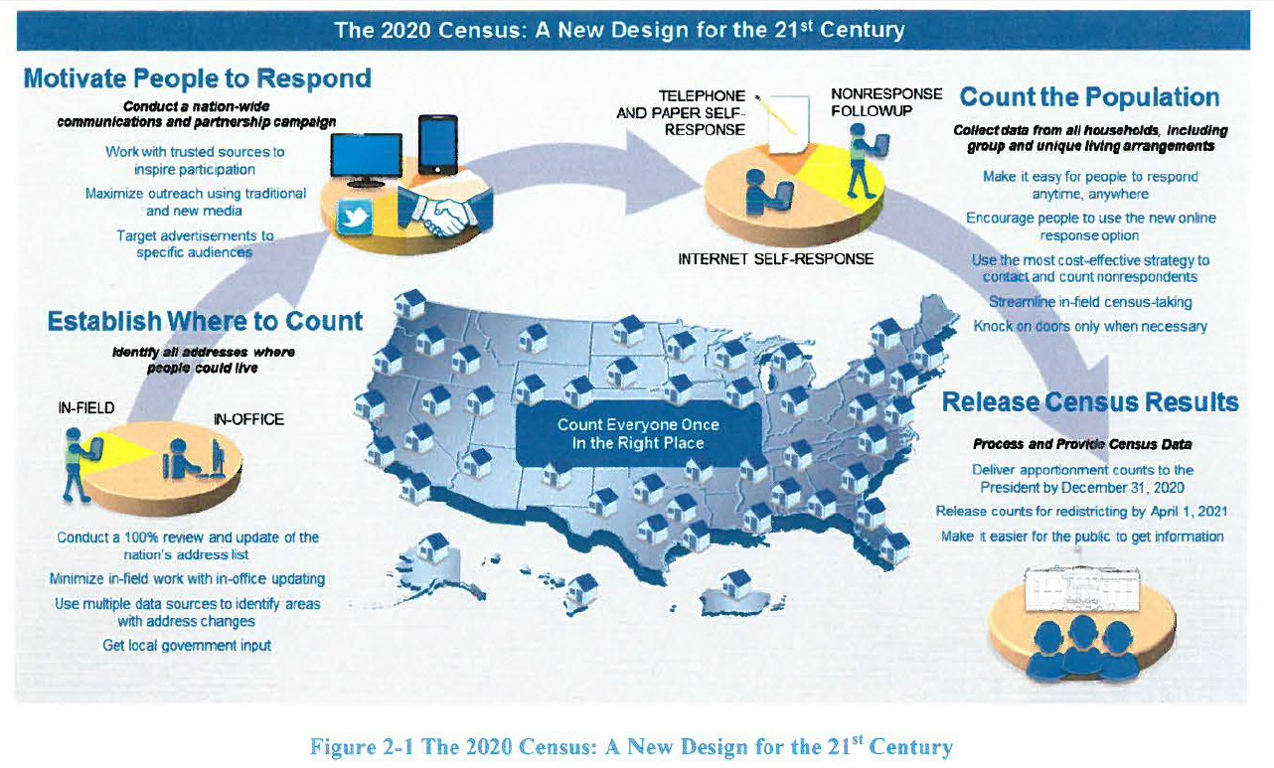

Successful execution of the 2020 Census will require coordinated efforts across a number of Census Bureau programs and will make use of resources from across the Census Bureau. The capabilities required to compete the 2020 Census are expected to be developed in an evolutionary fashion, with periodic large scale tests designed to exercise these emerging capabilities in realistic settings. Each builds successively from the prior tests, so that by the time of the first 2020 Census operations, the requisite capabilities are in place and have been field tested under realistic conditions.

## Operational Design Overview

The iterative development process described above, which is unlike past decennials, incorporates lessons learned from early research, testing, and analysis. The lessons learned drive updated requirements for capabilities and acquisitions. Another important difference for 2020 is the emphasis on enterprise standards and solutions, such as the CEDCaP and CEDSCI initiatives, both of which are expected to provide substantial support for the 2020 Census.

Another significant difference from earlier Census designs is the focus on innovations to improve efficiencies and reduce costs. The innovations in Reengineering Address Canvassing, Optimizing SelfResponse, Utilizing Administrative Records and Third-Party Data, and Reengineering Field Operations could potentially reduce the cost of the 2020 Census by over $5.2B as compared with repeating 2010 Census methods in 2020.

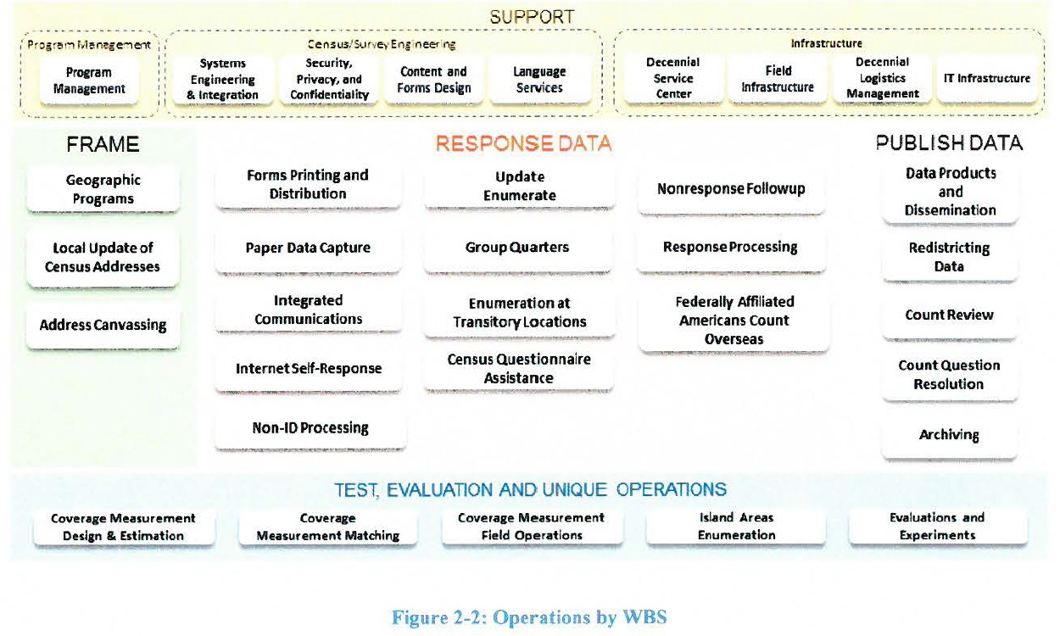

In addition to the four major innovations mentioned in Section 1, the 2020 Census will include a number of key innovations that impact many of the large, complicated operations. Innovations are considered significant changes to the operational design as compared to the 2010 Census. Figure 2-3 highlights in brown the operations have the most significant innovations. The specific innovations for each of these operations are listed in Table 1 below.

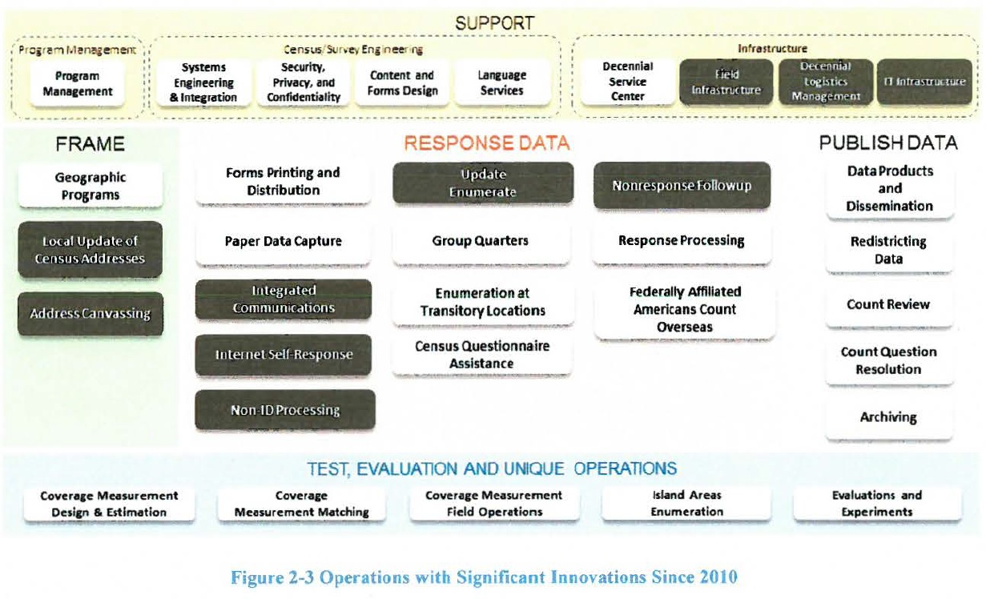

**Table I Summary of Key Innovations by Operation**

|  |
| --- |
| **Local Update of Census Addresses**  • Reduced complexity  • Elimination of the full address list submission options to improve quality and reduce burden and cost |
| **Address Canvassing (**Touchpoint**)**  • Use of a combination of In-Office and In-Field methods to achieve a 100 percent address canvassing (target of 25 percent of addresses going to In-Field)  • Use of automation and data (imagery, administrative records, and third-party data) for InOffice Address Canvassing  • Ongoing MAF Coverage Study to validate In-Office procedures, measure coverage, and improve In-Field data collection methodologies  • Use of reengineered field management structure and approach to managing fieldwork, including new field office structure and new staff positions |
| **Integrated Partnership and Communications**  • Micro-targeted messages and placement for digital advertising, especially for hard-to-count populations  • Advertising and partnership campaign adjusted based on respondent actions  • Letters, postcards, and questionnaires to motivate self-response  • Expanded predictive modeling to determine the propensity to respond by geographic areas  • Expanded use of social media |
| **Internet Self-Response**  • Internet data capture, providing real-time edits, ability to capture household entries, and multi-access methods across different technologies (e.g., computers, phones, tablets, kiosks)  • Online questionnaires available in multiple languages and non-Roman alphabets  • Multi-mode contact approach tailored to demographic or geographic area  • A phone option (via Census Questionnaire Assistance) will be available for respondents, who need help or without Internet access, to provide their census data.  • Paper questionnaires will be provided in the first mailing to some areas of the country, and will also be sent to all nonrespondents after a few weeks. |
| **Non-ID Processing**  • Ability for public to respond anytime, anywhere  • Real-time matching and geocoding of responses  • Validation of response data  • Use of administrative records and third-party data used to validate identity and validate and augment address data submissions |
| **Update Enumerate (planned innovations dependent on funding of this operation)**  • The 2010 Census Update Leave and Update Enumerate Operations combined into a single operation  • Single visit with enumeration or push to Internet Self-Response  • Use of single device for both listing and enumeration  • Use of reengineered field management structure and approach to managing fieldwork, including new field office structure and new staff positions  • Assignment and route optimization  • Automated training for field staff  • Automation of the field data collection  • Automation of administrative functions such as recruiting, onboarding, and payroll  • Reengineered quality assurance approach |
| **Nonresponse Followup**  • Use of administrative records and third-party data to remove vacant housing units from the NRFU workload  • Use of administrative records and third-party data to enumerate some nonresponding occupied housing units from the NRFU workload  • Use of reengineered field management structure and approach to managing fieldwork  • Use of a variable contact strategy and stopping rules to control the number of attempts made for each address (based on paradata)  • Assignment and route optimization  • Automated training for field staff  • Automation of the field data collection  • Automation of administrative functions such as recruiting, on boarding, and payroll  • Reengineered quality assurance approach  • The notice of visit will provide the Internet URL to still encourage self-responses |
| **Field Infrastructure**  • Reduced number of Regional Census Centers managing a reduced number of local field offices tasked with managing field operations and support activities  • Automated job application and recruiting processes, payroll submission and approval process, and other administrative processes resulting in reduced staffing requirements  • Automated training  • Reduced number of enumerators and supervisors due to reengineered design for field operations |
| **Decennial Logistics Management**  • Implementation of an on-line, real-time Enterprise Resource Planning (ERP) system with extended access for the Regional Census Centers and field offices  • Implementation of a wireless network and bar code technology that will automate inventory transactions |
| **IT Infrastructure**  • Early development of solutions architecture  • Use of enterprise solutions as appropriate  • Iterative deployment of infrastructure aligned with and based on testing  • Implementation of alternatives to providing Government Furnished Equipment such as Device as a Service  • Use of demand models to help predict Internet response volume, Census questionnaire assistance center staffing, etc.  • Scalable design  • Agile development of applications |

## Business Architecture Overview

The business architecture relies on the phased approach tests driven by a comprehensive list of the 2020 Census Architecture business requirements. Each test re-uses the existing solution and technologies to the extent possible, introduces new enhancements of existing capabilities and/or replaces older legacy systems with new solution initiatives. The general goals and objectives of each test are to support, evaluate, and modernize the existing solutions.

The business capabilities of the 2020 Census Solution Architecture align with the 34 Census business operations. The Census Bureau and the Decennial Program will conduct various tests that drive the incremental transition of the solution architecture. These tests and Censuses serve as effective tools in verifying the capabilities of each solution, while facilitating the design progression of the infrastructure to support the 2020 Census scalability requirements. The specific capability requirements and Business Process Model (BPM) diagrams for each Test as well as their business requirements can be found in the requirements repositories, and are managed by the Decennial Architecture Requirements Team (DART).

## Current Business Architecture

The information flows among the primary business operations for the 2015 NCT are highlighted in the Figure 4-1. Major interactions and flows are shown via the arrows in the diagram and the key external interfaces are depicted via labeled icons.

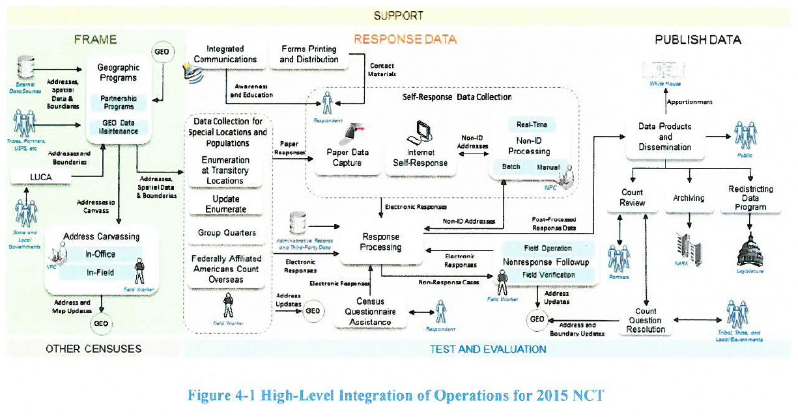

The operation that was primarily being informed by the 2015 NCT was the Content Forms and Design (CFD) and the contact strategy which is currently developed in Internet Self-Response (ISR), but executed through Forms Printing and Distribution (FPD).

The other operations that participated in this test were implemented to support this test, but were not the focus of the test in terms of answering the design questions.

The 2015 NCT includes multiple operational areas that collectively provide the anticipated capabilities that map to the end-to-end survey lifecycle and are grouped into five categories: support, frame development, response data collection, disseminate data, and test, evaluation, and other censuses.

• **The Support segment** addresses the needs for HR, IT, and Infrastructure support services of the 2020 Census. Support is comprised of the program management, survey engineering, and infrastructure operational categories.

• **The Frame development segment** entails activities within the geographic programs, LUCA, and Re-Engineered Address Canvassing. These activities support the task of developing administrative records frame, geographic delineations, and address canvassing. LUCA was not part of the 2015 NCT, although it is part of the Geographic Programs.

• **The Response Data Collection segment** is the largest segment within the 2020 Census Architecture where thirteen distinct operations work together to achieve the data/response information collection goals. The response data collection segment includes a multitude of enterprise and non-enterprise systems, the majority of which are scoped within CEDCaP.

• **The Disseminate data segment** is responsible for activities such as accurate production, review, and dissemination of the data collected by the response data collection segment and shared with the stakeholders. The disseminate data segment was not involved in the 2015 NCT.

• **The test, evaluation, and other censuses segments** include five operational areas with activities that address coverage measurements, matching, follow-ups of the housing units and interviews, enumerations, and experiments. The test, evaluation, and other censuses segments were not involved in the 2015 NCT.

**Target State Architecture**

The 2020 Census architecture is described in the context of the seven domains as shown in Figure 5-1.



The strategy domain consists of the program vision and mission level business requirements.

## Target Business Architecture

The information flows among the primary business operations are highlighted in Figure 5-2. Major interactions and flows are shown via the arrows in the diagram and the key external interfaces are depicted via labeled icons.

Although each operation is presented separately, the operations must work together to achieve a successful Census. Information flows among the operations as the census proceeds from frame development through collection of response data to the publishing and release of the data.

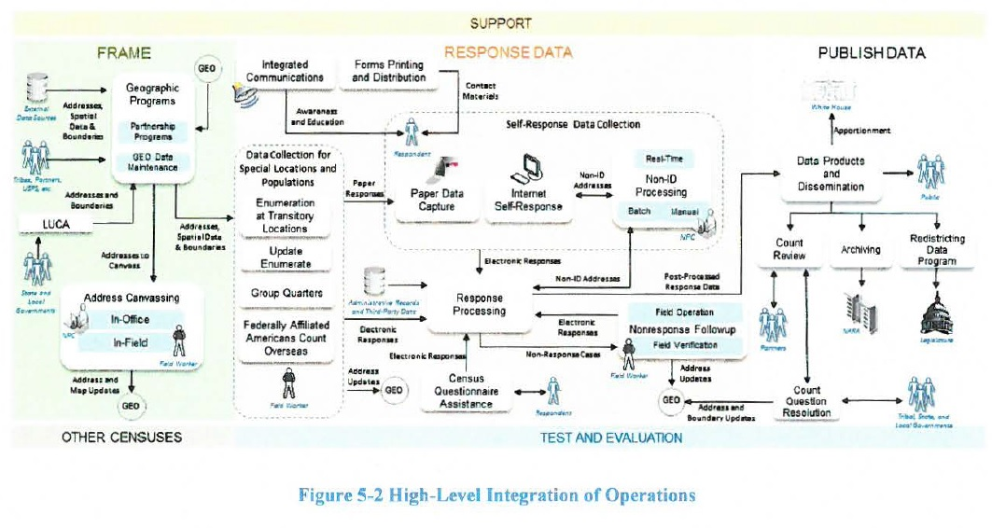

Figure 5-3 shows how the operations are divided into the business architecture categories.

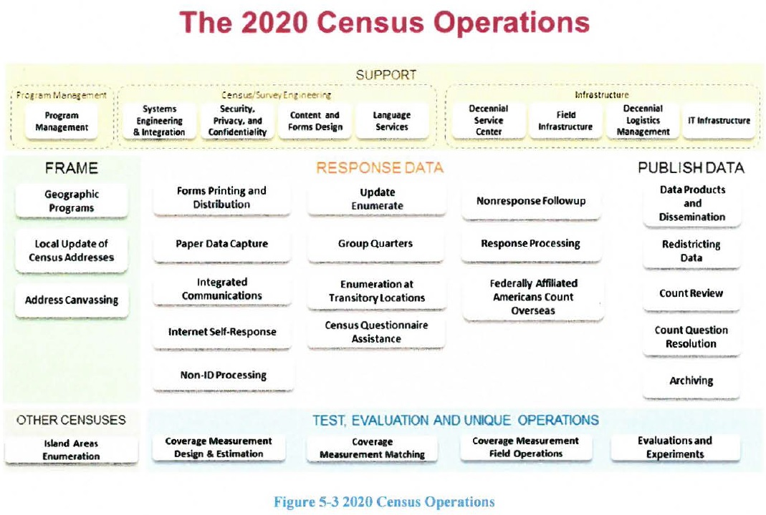

**The 2020 Census Business Architecture** describes the functional business process, the relationship, and the geography aspects of the business environment. It is decomposed into multiple operational areas that collectively provide the anticipated capabilities that meet the end-to-end survey lifecycle phase and is grouped into five categories: support, frame development, response data collection, disseminate data, and test, evaluation, and other censuses.

l. **The Support segment addresses** the needs for HR, IT, and Infrastructure support services of the 2020 Census. Support is comprised of the program management, census/survey engineering, and infrastructure operational sub-categories.

2. **The Frame development segment** entails activities within the geographic programs, LUCA, and Re-Engineered Address Canvassing. These activities support the task of developing administrative records input, geographic delineations, and address canvassing.

3. **The Response Data Collection segment** is the largest segment within the 2020 Census Architecture where thirteen distinct operations work together to achieve the data/response information collection goals. The response data collection segment includes a multitude of enterprise and non-enterprise systems, the majority of which are scoped within CEDCaP.

4. **The Disseminate data segment** is responsible for activities such as accurate production, review, and dissemination of the data collected by the response data collection segment and shared with the stakeholders, the majority of which are scoped within CEDSCI.

5. **The test, evaluation, and other censuses segment** includes five operational areas with activities that address coverage measurements, matching, follow-ups of the housing units and interviews, enumerations, and experiments.

## Two Touchpoints for Address Canvassing

1. **In-Office Address Canvassing**: 75 percent of all address canvassing will be “In-Office” using third party sources and administrative records along with Geographic systems.
2. **In-Field Address Canvassing**: Only 25 percent of remaining address canvassing will be “In-Field” resulting in large cost savings.

### Here is the Level-0 Activity Model for the overall Address Canvasing workflow:

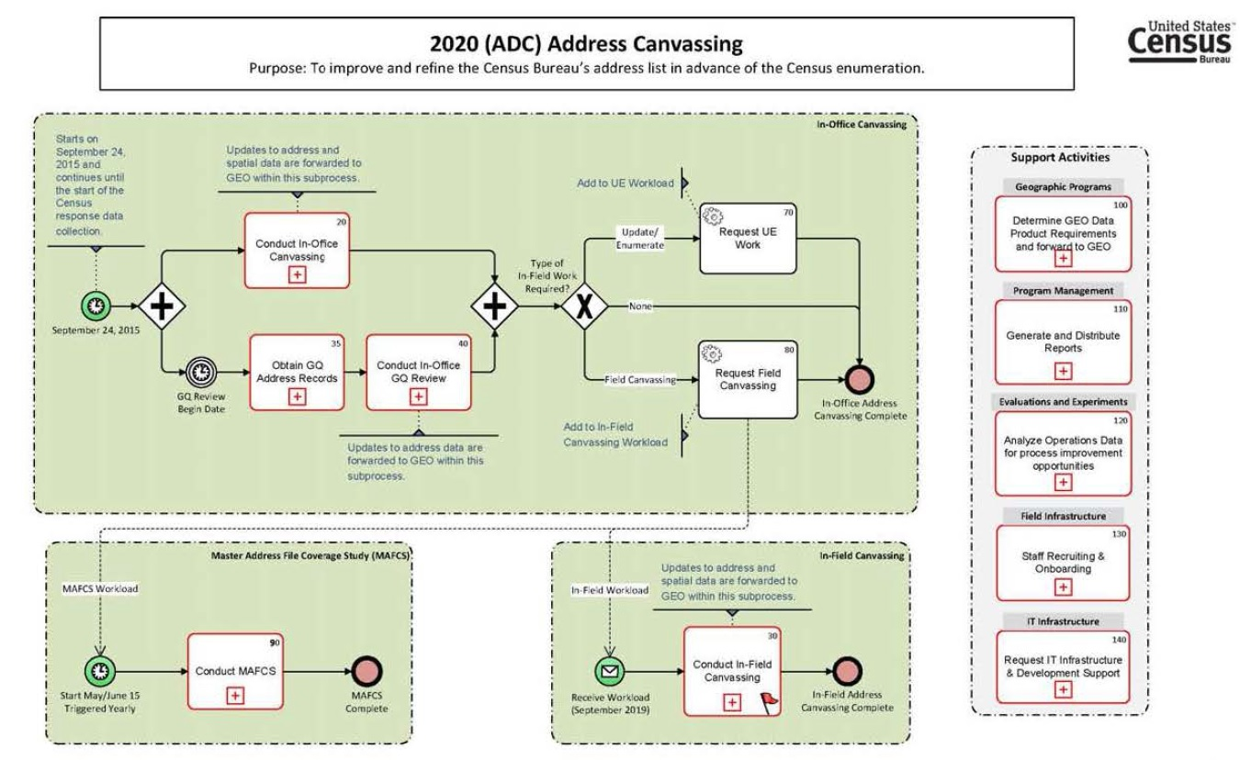

### Here is the Level-1 Sub-Activity Model for [In-Office] Address Canvasing workflow:

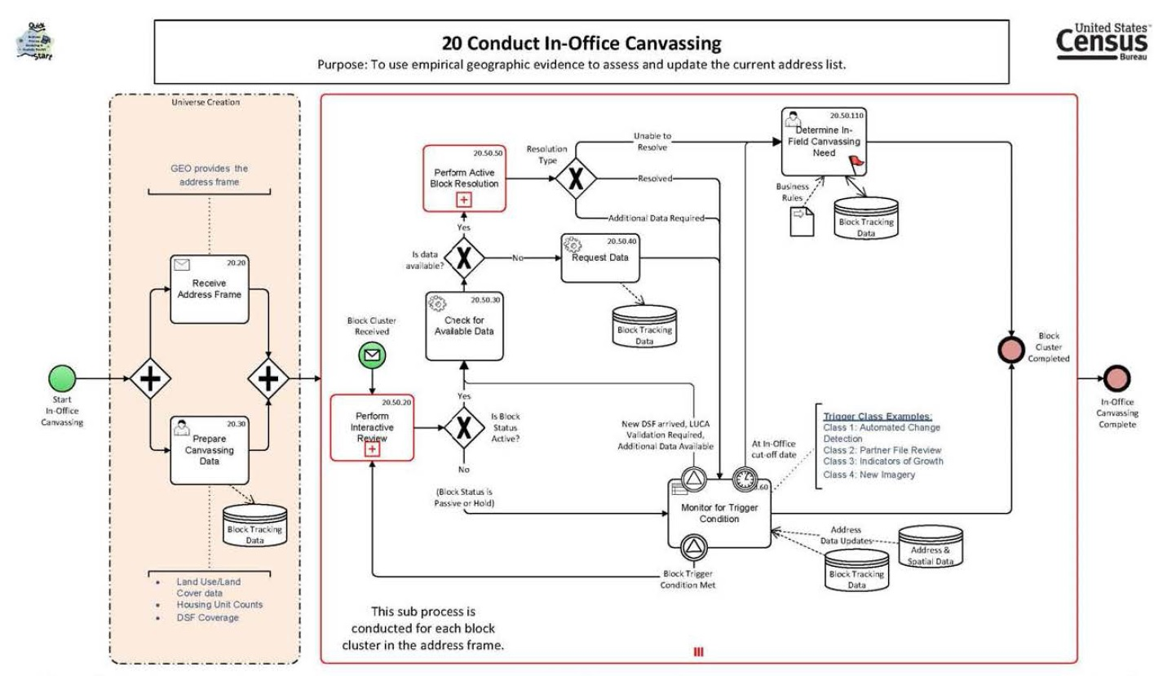

### Here is the Level-1 Sub-Activity Model for [In-Field] Address Canvasing workflow:

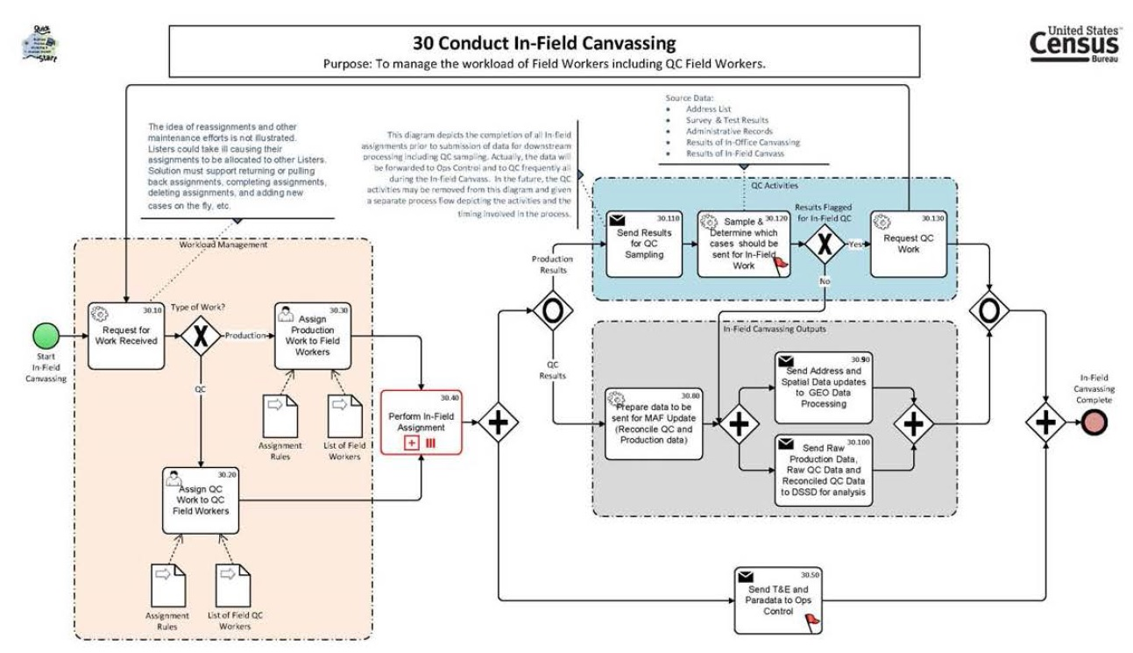

# **Summary of the system view from the 2015 NCT to the 2020 Census.**

The current state (2015 NCT) is a series of tests ranging from small to medium to determine operational readiness of systems. The 2015 NCT is considered the baseline. The main focus of the 2015 NCT was to test out multiple content forms with multiple mails out strategies.

The current state application architecture is a highly complex integration of existing and new solutions having different platforms, hardware and software, multiple data sources with some manual, and little automated process. It provides a context for system development or enhancement. Applications areas within systems represent a useful subdivision of activities, services, and data that can be linked to other objects in the architecture. They are a group of activities and entity types with strong interdependencies such that a single application or more than one application can support the area. In the past applications communicated often via manual processes to manager large transfer of data. Files were transferred manually using ad-hoc transfer solutions, such as FTP.

The Target state (2020 Census)is based on a SOA paradigm where each application will provide services to the overall solution. In providing these services, these applications, can dictate development of technical enhancements and defining design patterns, APIs, Web Services, use of ESB, mobile, and cloud technologies. The ability to allow applications to use integrates enterprise data models to communicate with other systems and share data.

This modernization will consider the interoperability and interfacing elements such as data format, type, size, frequency, and performance elements such as throughput, response time, and quality of service. Future state will utilize Enterprise Integration Patterns based on API, ESB, and Managed File Transfer (MT) software to securely and efficiently share data across systems.

The target state application architecture will be a set of application areas identified to support the 2020 census. It provides a context for system development or enhancement. Application areas represent a useful subdivision of activities, services, and data that can be linked to other objects in the architecture. There will be a group of activities and entity types with strong interdependencies such that a single application or more than one application can support the area.

Target state will consist of both legacy application enhancements and new application development efforts. Projects such as CEDCap will replace multiple legacy systems used during the 2010 Census, while other legacy applications such as CIRA will remain to support the 2020 Census.

# The System View

Current State System Architecture 2015

The current state application architecture is a highly complex integration of existing and new solutions having different platforms, hardware and software, multiple data sources with some manual, and little automated process. It provides a context for system development or enhancement. Applications areas within systems represent a useful subdivision of activities, services, and data that can be linked to other objects in the architecture. They are a group of activities and entity types with strong interdependencies such that a single application or more than one application can support the area. In the past applications communicated often via manual processes to manager large transfer of data. Files were transferred manually using ad-hoc transfer solutions, such as FTP.

Figure 4-2 shows how outputs from some systems feed into other systems via arrows.

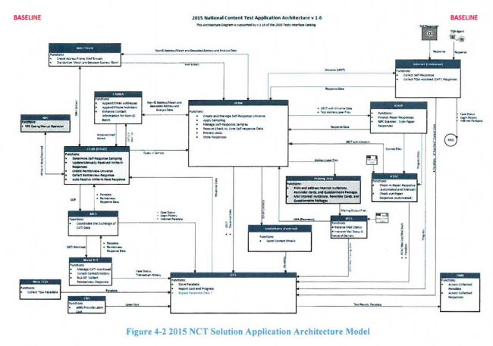

Target State System Architecture 2020

Based on a SOA paradigm where each application will provide services to the overall solution. In providing these services, these applications, can dictate development of technical enhancements and defining design patterns, APIs, Web Services, use of ESB, mobile, and cloud technologies. The ability to allow applications to use integrates enterprise data models to communicate with other systems and share data.

This modernization will consider the interoperability and interfacing elements such as data format, type, size, frequency, and performance elements such as throughput, response time, and quality of service. Future state will utilize Enterprise Integration Patterns based on API, ESB, and Managed File Transfer (MT) software to securely and efficiently share data across systems.

The target state application architecture will be a set of application areas identified to support the 2020 census. It provides a context for system development or enhancement. Application areas represent a useful subdivision of activities, services, and data that can be linked to other objects in the architecture. There will be a group of activities and entity types with strong interdependencies such that a single application or more than one application can support the area.

Target state will consist of both legacy application enhancements and new application development efforts. Projects such as CEDCap will replace multiple legacy systems used during the 2010 Census, while other legacy applications such as CIRA will remain to support the 2020 Census.   
  
Figure 5-4 shows how multiple systems will interact with both the legacy and new systems.

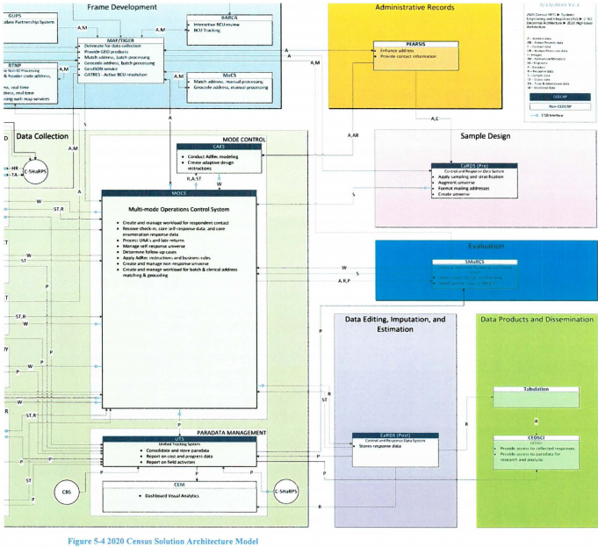

The Census System architecture view from 2015 to 2020 has several tests from current to target state.

2015 National Content Test (NCT)

The 2015 NCT evaluated and compared different census questionnaire content. The main focus was to test out multiple content forms with multiple mails out strategies.

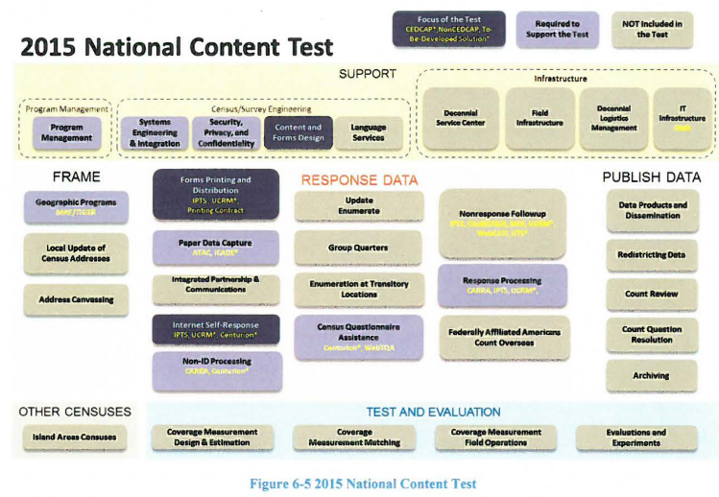

The 2016 National Census Test

Is designed to build on the 2015 NCT and introduce new systems and capabilities into the operational suite. The 2016 test focuses on the integration of self-response and Nonresponse followup operations. The introducing of CEDCap is meant to help with the self-response portion.

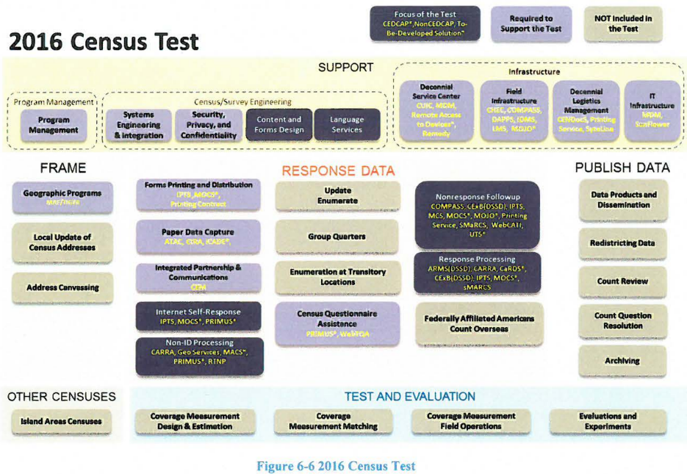

The 2017 Census Test and Address Canvassing (AdCan) Test

In 2017 the Census Bureau starts using the address canvassing (AdCan) test. The AdCan test is designed specifically to exercise new features to allow the Census Bureau to add new addresses to the existing address framework by using geographic information systems, aerial imagery and other data sources instead of sending Census Bureau employees to walk and physically check 11 million census blocks.

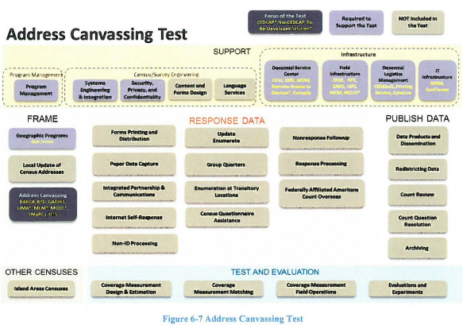

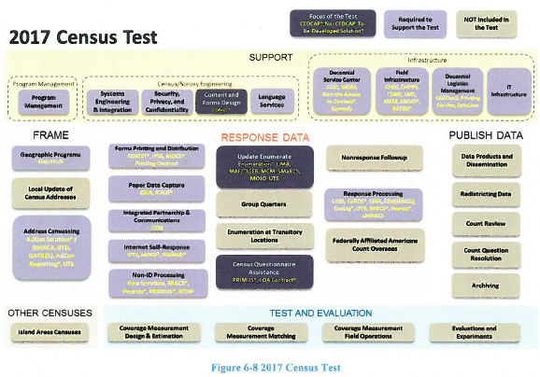

The 2018 End-to-End Census Test

The 2018 test is designed to be a large scale test for the 2020 Census. The intent is to fully exercise all major operations and systems in preparation for the Decennials counts. The goal is to have operational designs ready for production especially from a systems perspective.

The 2018 test is intended to mirror what will happen for 2020. The actual amount of data collected will not be as much as the 2020 census but false data will be used for stress testing. One of the main goals of the 2018 test is to automate some of the systems that were heavily manual in 2010 using the Coverage Measurement System. The Coverage Measurement system will take advantage of the centralized person-matching system that will be created for the 2020 Census efforts.

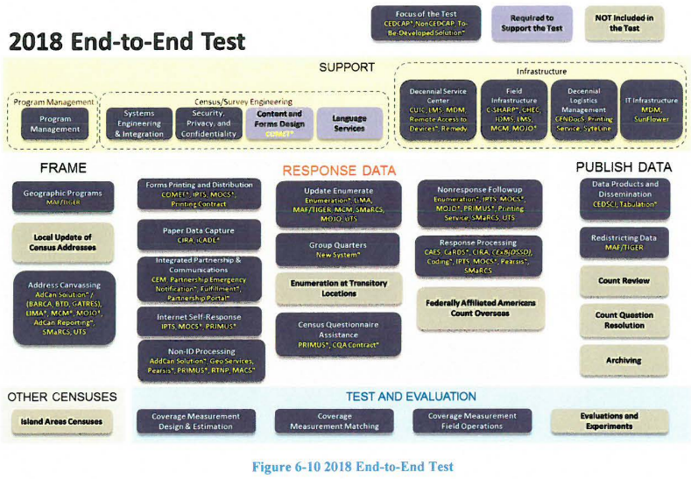

The 2019 Testing

There will be two types of testing for 2019. Defect resolution testing and Post End-to-End performance testing. The defect resolution testing will make sure that any changes made to fix defects from the 2018 test are resolved for the 2020 test. The Post end to end test will ensure that the solution as a whole is satisfied scalability, availability, and reliability.

The 2020 Decennial Census

The 2020 Census will be the actual census conducted to meet the constitutional requirement of determining the United States population every 10 years. The 2020 census will take lessons learned from the past 5 years and hopefully incorporate those into a successful census. That will make best use of resources used, time spent, and overall quality of data.

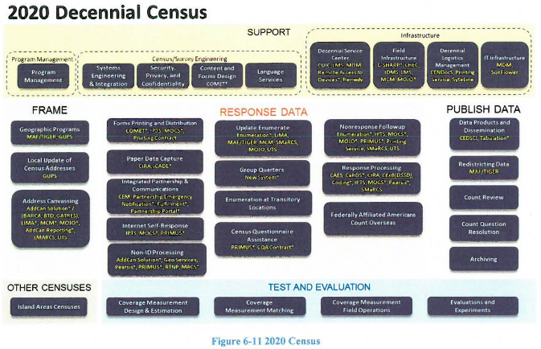

Main systems to be used:

Unified tracking system-Is an existing application used by Field ROs and Headquarters survey managers. The UTS will require changes to the existing interfaces, the ability to generate new reports, change old reports, in order to support the address canvassing operating.

Operational control system-will be used to manage the in-field address canvassing with the ability to create list crews of workers, make assignments, and generate reports both daily and in near real time.

Lima-part of CEDCAP program-Intially built for laptop but will be introduced on a handeld for mobility. Lima captures the GQ data for AdCan test that has not previously been captured.

National Finance Center- will perform payroll/personnel functions for field staff.

MCM-part of CEDCAP program-will be used for mobile case management.

SMaRCS-Based on the MaRCS 2010 system, performs re-interview QC sample selection and re-interview case matching to detect false data.

CARRA-Will be used to support administrative records for modeling and optimizing NRFU workload operations.

CEM-Will be used for data analytics, reporting customer exeriences, and importing response data from the old CaRDs system.

MaCs-Will be introduced to support manual matching and address geocoding of Non-ID cases.

# The Technical view

## IT Infrastructure

According to the definition of Information Technology Infrastructure Library (ITIL) v3, IT infrastructure a combination of tools and methods such as hardware and software to help to develop, deliver and test IT services. The goals of ITIL are cost reduction, IT services improvement, customer service improvement, technology productivity improvement delivery enhancement.

The architecture will use the enterprise cloud services. It should address the cloud solution readiness and the detailed strategy to meet the 2020 solution architecture. A lot of interfaces which are expected to use ESB and web services should communicate and share files efficiently and securely.

The enterprise IT Infrastructure should be refreshed periodically with timelines including compute resources, storage, network devices, system monitoring, and security appliances. The technology refresh timelines must be aligned with the Census Tests timelines and 2020 Architecture Transition Plan so to ensure readiness of the infrastructure components for Census Tests and 2020 Census.

## Service Oriented Architecture (SOA)

A service-oriented architecture (SOA) is an architectural pattern in which an application component provides services to other components by communication protocols over a network.

The Census Bureau has adapted SOA as a way to deliver on its mission requirement. The SOA increases the ability to adapt changes more rapidly as well as meets business and technical needs of the agency. The SOA strategy will enable the US Census Bureau to:

* Decrease architecture complexity and increases the application integration more efficiently.
* Provide the data and application APIs to systems, which are accessible throughout the enterprise.
* Deliver applications faster with lower system integration costs.
* Provide support for application services reuse and enable business functions to operate more efficiently.

The 2020 Census solution architecture is based on the SOA paradigm. The services and interfaces of one system need to share data with other systems in the solution architecture. The SOA includes not only in-house services, but also Platform as a service (Paas) and Software as a service (Saas) models.

The important part of SOA, ESB facilitates the integration of loosely coupled services within the

architecture. ESB is a common implementation pattern for SOA and its objective is to find a standard, structured, and general solution for implementing loosely coupled software services. The 2020 solution architecture goal is to transition into the ESB and be able to effectively and efficiently transfer messages and data files across the platform.

## Mobile Technology - Device as a Service (DaaS)

The 2020 Census Architecture will be transition to Device as a Service (DaaS). Implementation will allow a transition to being directly connected to the US Census network to record secure electronic data collection and transmission of Census results.

## Enterprise Cloud

Enterprise cloud computing environment provides software, infrastructure and platform services to an enterprise. Cloud computing eliminate systematic risk rising from power grid interruption and data loss due to network attacks. The US Census Bureau plans to migrate any component included in the Technical Reference Model (TRM). The fitness evaluation steps of migration process are shown in Figure 1.

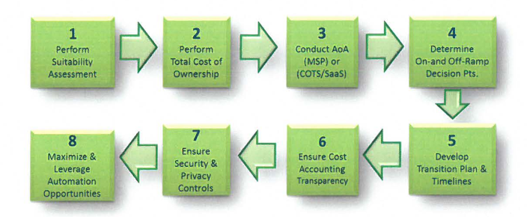

Figure 1.Key Strategic Steps for Consideration to Enterprise Cloud

* **Perform suitability assessment** on technology/architecture to determine readiness or potential for

a cloud solution.

* **Perform a Total Cost of Ownership (TCO)** including an AoA to see if a commercial managed service

provider (MSP) or COTS/Saas is more appropriate to deliver the capability.

* **Determine appropriate on-ramp and off-ramp**, either in a tech refresh, or a move to a different

cloud service provider (CSP), while considering alignment with other technologies that have

dependencies or a specific application is dependent on.

* **Ensure appropriate security and privacy controls** including records retention can be achieved with

the solution.

* **Ensure cost accounting and transparency** can be achieved with the solution. Consider what to

purchase, how to monitor and control costs, and ensure appropriate levels of service(s) are provided for payments made.

* **Develop transition plan** and schedule to include a WBS that aligns resources to the various

activities.

* **Maximize and leverage automation opportunities**- It is important to recognize possible areas and

opportunities to automate and optimize technical and business operations.

## Disaster Recovery and Continuity of Operation Plan (COOP)

The US Census Bureau places a high value on being prepared for disasters and operation continuity.

Failure from disaster recovery will lead to a loss of public confidence, risks of public safety and costly service downtime.

## Security Architecture

The Census Bureau Office of Security {OIS) has established security policies and guidelines at the

program, enterprise and system levels. In adherence with the security policies, the system owners and

program offices are required to register each system where they are responsible for its operation into

the eSDLC program. The transition to the 2020 Census architecture involves validating the security of nearly 60 systems.

## Program-Enterprise-System Quality

Quality data gathering, processing and storing is a high-priority goal of the 2020 Census. The US Census gathers data of variety nature and size some of which is considered personal and confidential. Therefore, quality in gathering such information securely is critical. The 2020 solution architecture considers four categories of quality; they are:

* Business/Program quality - Ensures governance processes, timelines, and milestones are

realistic.

* Enterprise quality - Ensures enterprise level services, integrations, and tools operate as designed

and intended.

* Data Quality- ensures the overall Census Count is accurate.
* System Quality - ensures higher-quality data capture via entry by human or machine (e.g. scanning solution), or via interfacing with other internal and external systems.

The aspects of quality, which accompany the expansion of the business functionalities, are further

described below and are presented by Figure 2, which indicates that as each solution's capabilities expand, the quality aspects of the target architecture will increase.

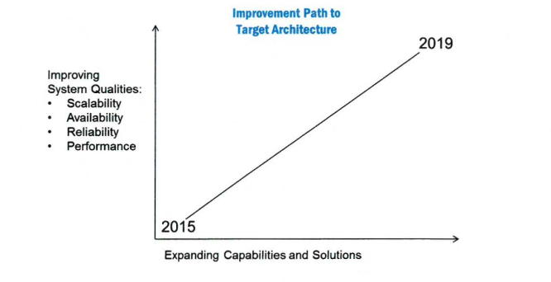

Figure 2.Quality Aspects vs. Expanding Capabilities and Solutions

## Scalability & Performance

Scalability refers to the ability of a system, network, or process to adapt and handle change in workload capacity and process demands. Elasticity is the ability to dynamically provide additional resources when load increases, and to tear down unused resources when demand wanes.

Currently a 2020 Census Architecture scale-up initiative is underway led by a three stage model, the conceptual, analysis, and implement/test. The conceptualize stage starts the process by producing several artifacts. They are the demand models, and the Non-functional requirements. The analysis stage realizes the overall solution, system, data flow, and interfaces while the Implement/test focuses on execution and testing of the analyzed models, using optimization, partitioning, replication, design.patterns, scaling and continuous testing techniques. This model is shown in Figure 3.

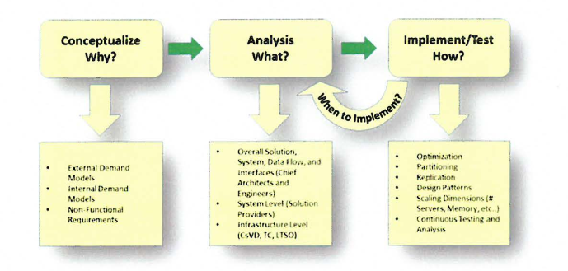

Figure 3.2020 Scale-Up Three Stage Process

The need of the workload to scale up will increase and during the transition period, the goal is to test and demonstrate the ability to scale up to full 2020 Census size. Figure 4 illustrates the Scale-up readiness timelines that the team has developed and when a scalable solution will be ready.

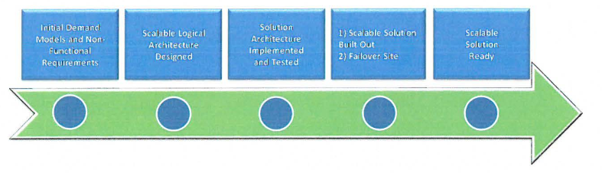

Figure 4. Scale-up Initiative Transition Timeline

## Availability & Reliability

A system is considered reliable when it continues to operate as designed and availability is the probability that a system will work as required for the duration of its mission. Availability of a solution is represented by the ratio of the expected value of the uptime (operational time) of a system to the sum of the expected values of the up and down times (operational) +(non-operational) as shown below.

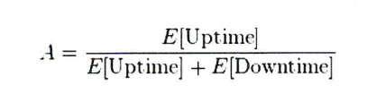

Figure 5. The definition of availability

During the transition period, the goal is to determine the accepted level of system availability for each system. This will help determine the thresholds of availability for mission critical and non-critical systems and help determine the overall architecture functional availability to conduct the census.

## Transition Approach

There are two standard approaches to develop an architecture based on the industry standard.

* **The baseline first approach** is used where an assessment of the baseline landscape is used to identify problem areas and improvement opportunities.
* **The target first approach** is used where the target state solution is elaborated in detail and then mapped back to the baseline, in order to identify change activity.

In determining the current and target states the Architecture team teamed up with various teams and

stakeholders to ensure a current state is precisely established. Figure 5 illustrates the communication and collaboration between stakeholders and program/project teams as well as the security and information engineers.

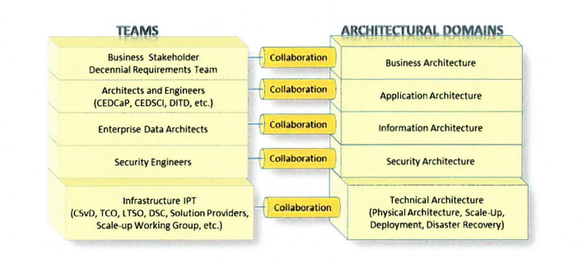

Figure 6. Architectural Domains and Team Collaboration

## Transition Steps

Transition steps need to consider the complexity and diversity of the architecture. Figure 6 defines a transition path. These steps are similar to the Enterprise Architecture Planning(EAP) model. Firstly, define where we are now and where we want to be, and then make gap analysis and work out migration plans.

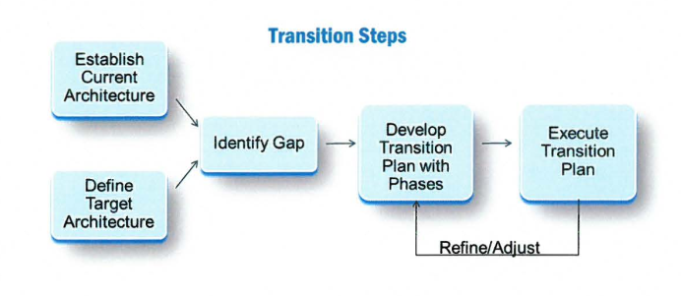

Figure 7. 2020 Census Architecture Transition Steps

## Phased Testing

Figure 7 illustrates the phased testing approach supported by detailed operation plans, GOSC and requirements as well as enabling technologies such as SOA, Cloud and Mobile. The transition is phased and promoted incrementally from its current state to the target state. For each phase test and census, a specific solution architecture diagram is developed, verified and validated by the appropriate stakeholders.

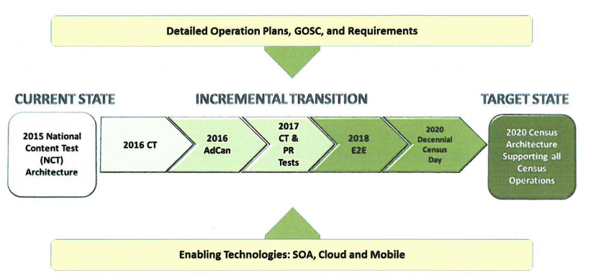

Figure 8. 2020 Census Architecture Incremental Transition Model

## Transition Tasks & Activities

To ensure timely execution of each test and census, the Architecture Team will continue to execute on   
on-going tasks and activities. Table 1 documents the transition tasks and future activities.

|  |  |
| --- | --- |
| Activity | Description |
| Finalize Target State Application Architecture | 1) Collaborate with Business Stakeholders and Business Requirements Team to  analyze the Operations that are in the process of developing the Detailed  Operational Plans, including requirements, Business Process Models, and  Integrated Operation Diagrams. One venue is to participate in the IPT sessions.  2) Identify solutions that are needed for new capabilities, by leveraging existing systems, enhancing existing systems, or designing new systems, such as Island Areas, Coverage Measurement (CM), and Group Quarters (GQ), etc. |
| Disaster Recovery and COOP | Collaborate with the COOP Team to establish and analyze the COOP and ; Disaster Recovery requirements |
| Scale-up Project Next Steps & Continuous Quality Improvement | Establish a Working Group to plan and execute the Scalability Framework encompassing the overall 2020 Solution Architecture, and all layers of the technology stack |
| IT Infrastructure Support | a) Working Group established to design the IT Infrastructure, including Field offices, in order to support the 2020 Census Operations and systems in  terms of capacity, scalability, reliability and system administration and monitoring.  b) This effort will include the analysis and design of a failover site for Disaster  Recovery and COOP.  c) Ensure the readiness of IT Infrastructure by aligning the Census Test dates  with the Technology Refresh phases. |
| Cloud Transition | Collaborate with Enterprise Services Framework Team and IT Divisions to establish a systematic plan to transition suitable systems that support 2020 Census to the Cloud environment. |

Table 1. Transition Tasks and Future Activities

## Current Architecture (As-is Architecture)

## Infrastructure Architecture

The 2015 NCT conforms to the Technical Reference Model {TRM) to guide the design of operational and

development environments and communication services for the 2020 Census solutions.

## Security Architecture

The 2015 NCT architecture was designed to be in compliance with all Census Bureau, Department of  
Commerce, and applicable government security standards.

## Quality Architecture

Data quality is a major focus of the Geographic Programs infrastructure due to their involvement with

checking for indications of growth and change and determining if the resources are available to make

updates and capture those changes.

## Target Architecture (To-be Architecture)

## Infrastructure Architecture

### Infrastructure Domains

Infrastructure encompasses several distinct domains of functionality and technology. The domains are as follows:

* Application Technology- Standards and software applications, which support the development, and integration of software applications.
* Collaboration and Electronic Workplace-Software applications, Standards and software applications.
* Networking and Telecommunications - Standards, software applications, and hardware that

provide or support computer networking and telecommunications.

* Infrastructure Platforms and Storage - Standards, software applications, and hardware that

support digital data computation and storage.

Figure 8 illustrates the infrastructure domains and associated sub-domains within the TRM

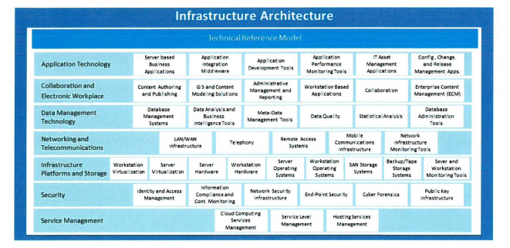

Figure 8. TRM Domains and Sub-domains

### Security Architecture

The Federal Information Security Management Act (FISMA) requires that all federal agencies document  
and implement controls for information technology systems that support their operations and assets.

### Quality Architecture

### Data Quality Management

The primary goal of the 2020 Census is to collect complete, accurate, and quality Census data.

### Data Quality in Systems

Various systems contribute to the quality aspect of the 2020 Census in two ways. The first way is

through systems that support Quality Control. The second way is through systems that have improved algorithms to support quality and efficiency modeling.

# References

Bureau, US Census. "What We Do." What We Do. N.p., 30 Jan. 2017. Web. 06 Apr. 2017.

“2020 Census Enterprise Architecture and Infrastructure Transition Plan: A New Design for the 21st Century” Issued 4/13/2016. Version 1.0

<https://www.census.gov/programs-surveys/decennial-census/2020-census/planning-management/planning-docs/enterprise-arch-transition-plan.html>

“2020 Census Detailed Operational Plan for the Address Canvassing Operation”. December 31, 2015. Version 1.0

<https://www.census.gov/programs-surveys/decennial-census/2020-census/planning-management/planning-docs.html>

“2020 CENSUS INTEGRATED COMMUNICATIONS CONTRACT: Request for Proposals”

<https://www.census.gov/about/business-opportunities/opportunities/vendor-opps/2014-10-15-2020-comm.html>